**EXNO:9  
ROLLNO:220701001**

**IMPLEMENTATION OF DECISION TREE CLASSIFICATION TECHNIQUES**

**AIM:** To implement a decision tree classification technique for gender classification using python

.  
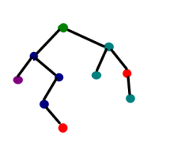

**CODE:**from sklearn.tree import DecisionTreeClassifier

import numpy as np

X = np.array([

    [170, 65, 42],

    [180, 75, 44],

    [160, 50, 38],

    [175, 70, 43],

    [165, 55, 39],

    [185, 80, 45]

])

Y = np.array([0, 1, 0, 1, 0, 1])

clf = DecisionTreeClassifier()

clf.fit(X, Y)

new_data = np.array([[168, 52, 38]])

prediction = clf.predict(new_data)

print("Predicted gender:", "Male" if prediction[0] == 1 else "Female")

**OUTPUT:**



